Program Purpose:

The program aims to facilitate access to medical consultations through a Electronic platform, helping patients obtain convenient and fast healthcare without having to go to the hospital.

**Problems it solves:**

1-Inability to access healthcare: Some people face difficulty in reaching hospitals due to lack of transportation or long distance.

2-Long waiting in queues: Waiting for a long time to obtain medical advice is a major challenge for patients.

3-Concern about infection: Some may avoid going to the hospital due to infection.

Needs it addresses:

Providing immediate remote medical consultations to patients. -

Continuous support for common health problems without having to visit hospitals. -

Access to reliable medical information to help them understand their symptoms. -

We conducted a survey of students to collect their opinions about this program and the result was as follows:

Based on the survey results, several points emerge about the importance of the program and improving program implementation

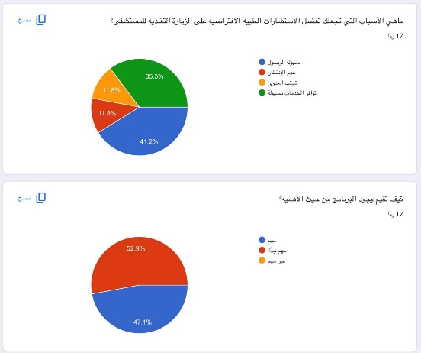



The reasons that make students prefer virtual consultations vary between ease of access (41.2%), not needing to move (35.3%), in addition to infection concerns.

The conclusion shows that most students consider virtual medical consultations important, as 52.9% feel that the presence of the program is very important and effective

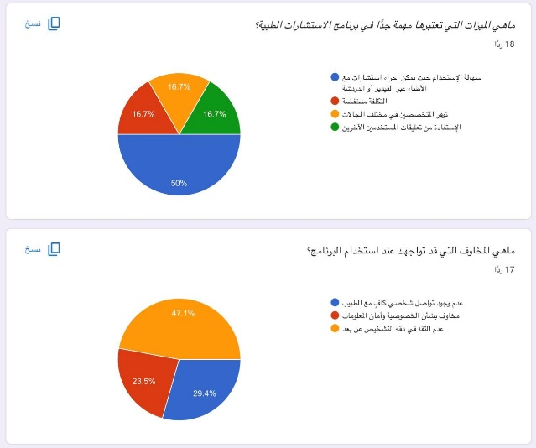

Among the important advantages that students expect are ease of use (50%) and reducing costs (16.7%). These points indicate that the program can attract more users if it focuses on simplifying the process and providing lower costs compared to going to hospital.

The most common concerns are the lack of personal communication with the doctor (47.1%), and concerns related to privacy and information security (29.4%). These concerns must be addressed by providing data protection and providing effective means of communication that allow the patient to feel comfortable...

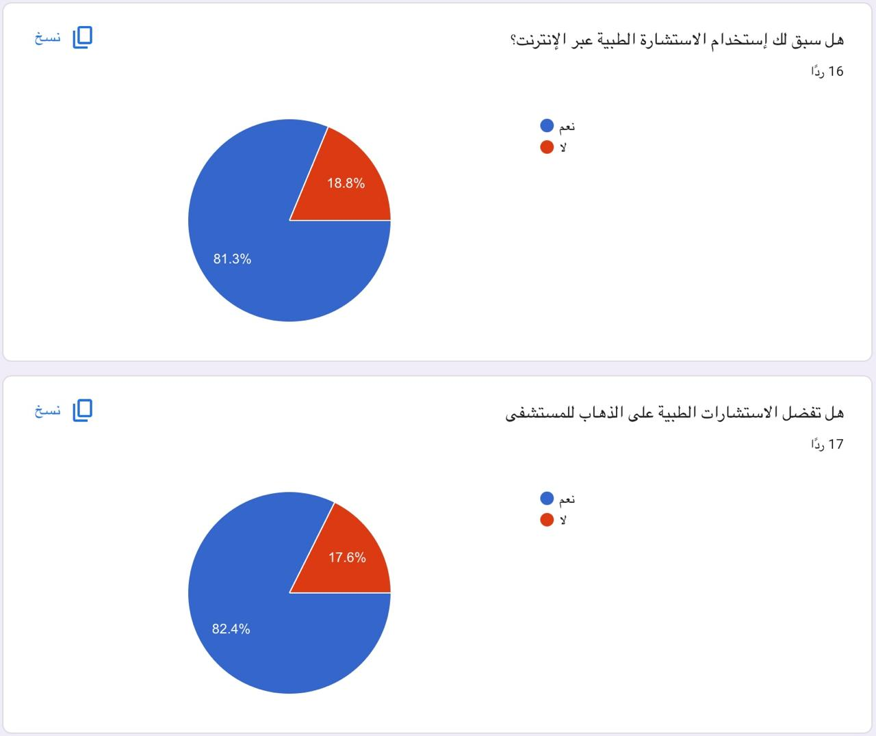

81.3% of students have previously used online medical consultations, indicating that this service has begun to gain wide acceptance among students.

How to improve the program:

1-Improve communication between patients and doctors:

Provide effective ways of personal communication so that the patient feels comfortable and reassured

2-Enhance protection and security:

Provide a strong security system that protects users' health information and personal data

3-Ease of use:

Ensure that the system is easy to use, and provide users with a guide on how to use it effectively

There is a similar program for **digital care**:

Teladoc Health

-Advantages: -

Provides medical consultations via phone or video.

Available 24 hours a day.

Disadvantages: --

The cost of services may be high for some users.

Lack of specialists in all health fields.



|  |  |  |
| --- | --- | --- |
| Teladoc Health | digital care | In terms of |
| -Phone or video consultations with professional doctors  -Special services including mental health, dentistry, and other medical services  -Provides archives of health problems and the ability to communicate with specialist doctors | -Instant remote medical consultations.  -Support for common health problems.  -Providing reliable medical information.    -Telephone or video consultations with professional doctors. | Services provided |
| -Saves patient waiting time by providing instant consultations  -Addresses challenges related to accessing care in isolated areas  -provides medical support to patients who are afraid to go to hospitals | Lack of access to health care -  -Long waiting times for consultations  -Concern about infection, especially during epidemics | Problems it solves |
| Simple and easy to use interface but may require some initial registration. | focuses on facilitating appointments and consultations according to the user's schedule. | Ease of use |
| Service costs may vary and often require subscriptions | It can be more financially convenient for students or low-income groups because it is low cost | Cost |

digital care VS Teladoc Health:

Rahma ali: 444007907

Aryam Hassan: 444003032